***Lewis University***

**Course: OBJECT ORIENTED DEVELOPMENT**

**Professor: Fadi Wedyan**

**Assignment – 1**

**Empirical study: effect of class size on software maintainability**

**Group Members:**

1. **Arun Bhattiprolu (Lewis id:L30080554)**
2. **Karthik Amanaganti (Lewis id : L30079466)**

**GitHub URL:**

**https://github.com/abhattiprolu/OOD.git**

***Section1***

***An overview about GQM:***

It is a popular research strategy in both academia and industry. This was created at the Goddard Space Flight Center for a number of NASA programs. Based on the premise that in order to measure something purposefully, a study must first identify its goals and then link those goals to the data used to describe them.

***Goal:***

Our goal is to perform empirical study: effect of class size on software maintainability.

***Question:***

Q1) How effective is the CK metrics tool?

Q2) How to increase the maintainability of a project?

Q3) which metrics need to be taken care of?

Q4) what metrics should be studied to take project maintainability into consideration?

Q5) Are the metrics directly proportionate or inversely?

***Metrics:***

We are considering CK metrics for the analysis i.e. the metrics for measuring maintainability

***Section2***

Data sets

|  |  |  |
| --- | --- | --- |
| Sno | Program Name | Description |
| Project1 | ksqlDB | ksqlDB is a database for building stream processing applications on top of Apache Kafka. It is distributed, scalable, reliable, and real-time. ksqlDB combines the power of real-time stream processing with the approachable feel of a relational database through a familiar, lightweight SQL syntax. ksqlDB offers these core primitives |
| Project2 | Apollo - A reliable configuration management system | Apollo is a reliable configuration management system. It can centrally manage the configurations of different applications and different clusters. It is suitable for microservice configuration management scenarios.  The server side is developed based on Spring Boot and Spring Cloud, which can simply run without the need to install additional application containers such as Tomcat. |
| Project3 | Arthas | Arthas is a Java Diagnostic tool open sourced by Alibaba.  Arthas allows developers to troubleshoot production issues for Java applications without modifying code or restarting servers. |
| Project4 | Netty Project | Netty is an asynchronous event-driven network application framework for rapid development of maintainable high performance protocol servers & clients. |
| Project5 | APIJSON | Tencent is pleased to support the open source community by making APIJSON available. |

***Section3***

The tool used here in the assignment is “CK-Code metrics for Java”

***Object-Oriented Quality metrics:***

Developed by Chidamber and Kemerer and popularly known as the (C&K) metrics suite.

Created to: Evaluate OO software characteristics, Calculate the design's complexity,

more effective software development. The metrics include:

* WMC (Weighted Methods per Class)
* DIT (Depth of Inheritance Tree)
* NOC (Number of Children)
* CBO (Coupling Between Objects)
* RFC (Response for Class)
* LCOM (Lack of Cohesion of Methods)

Among the above metrics WMC, CBO, RFC, LCOM can be used to measure maintainability.

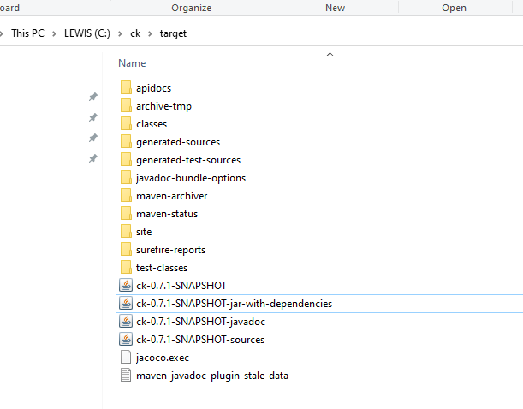

I have downloaded the tool from Github.

***Section4***

I have cloned the following projects provided from the Git and executed the jar file:

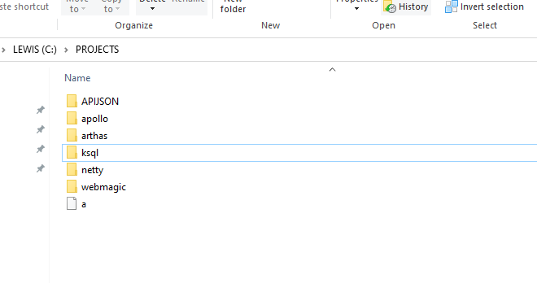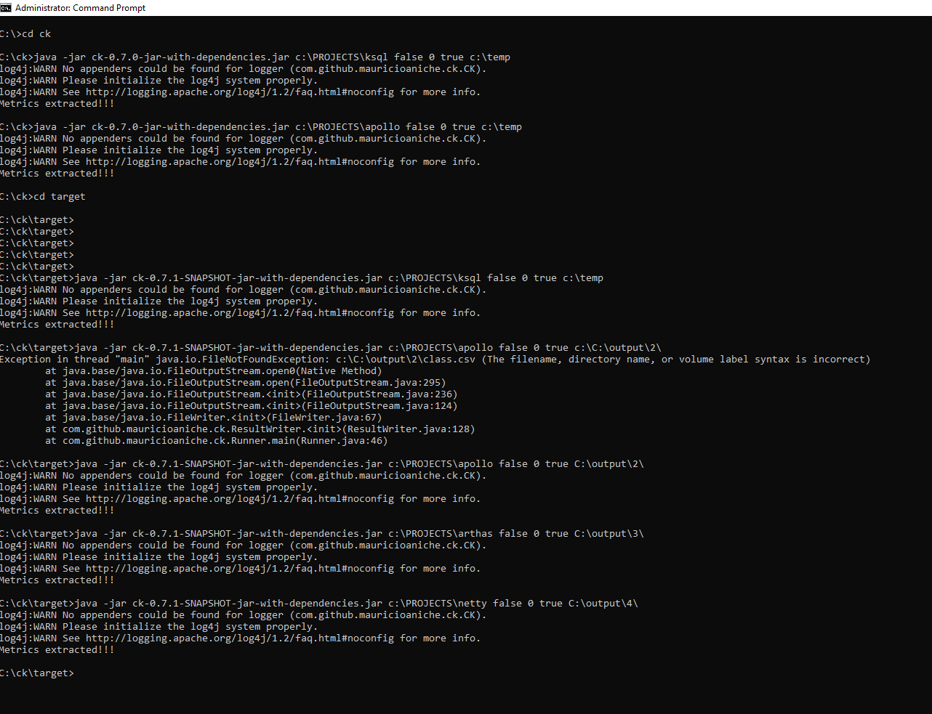

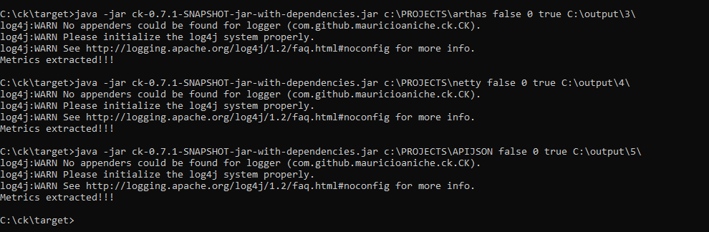

Project1: Ksql

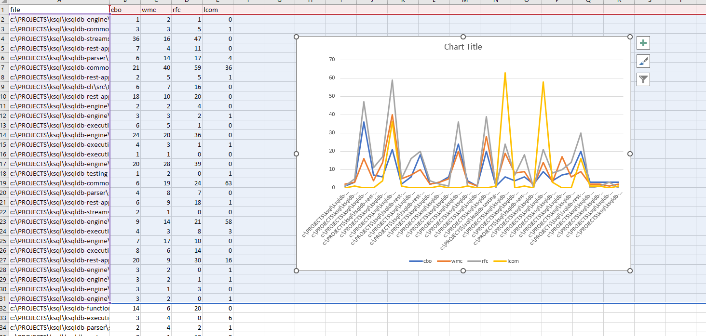

Project2: Apollo

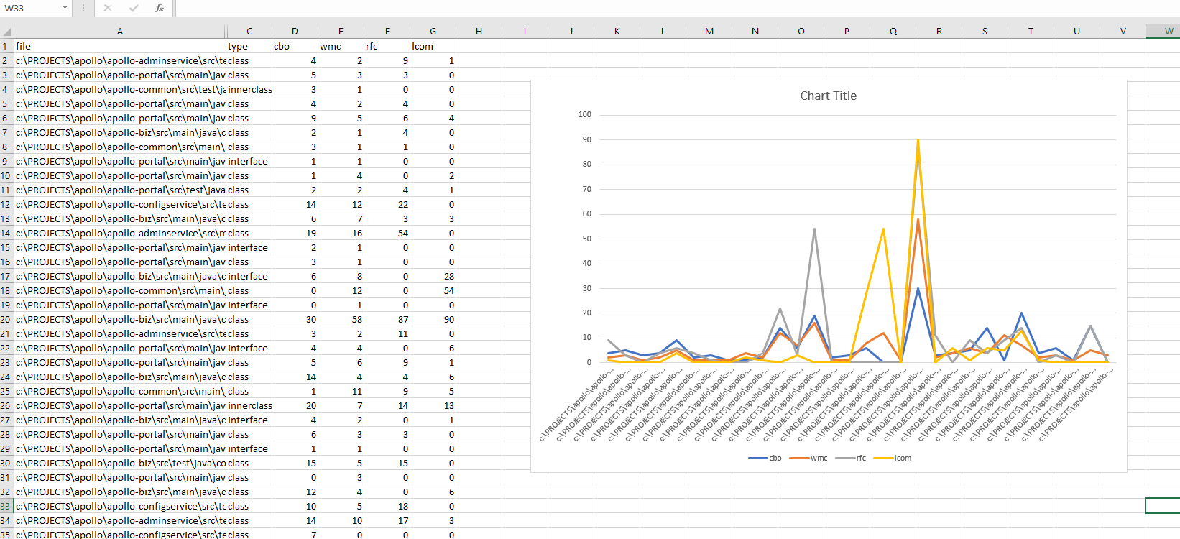

Project3: Arthas

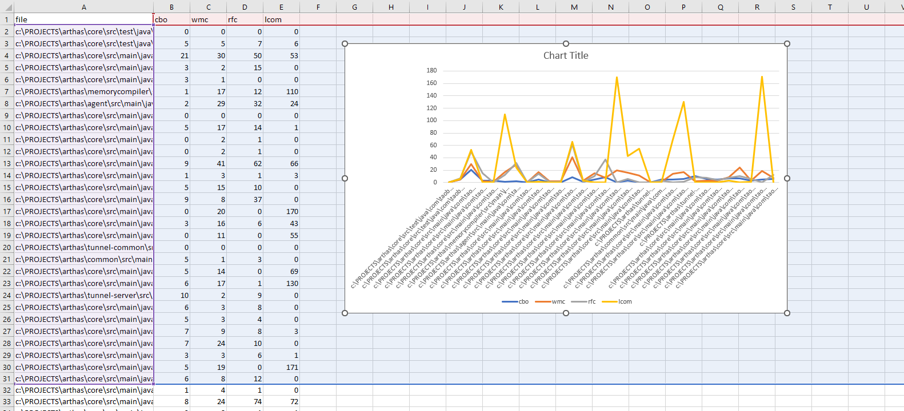

Project4: Netty

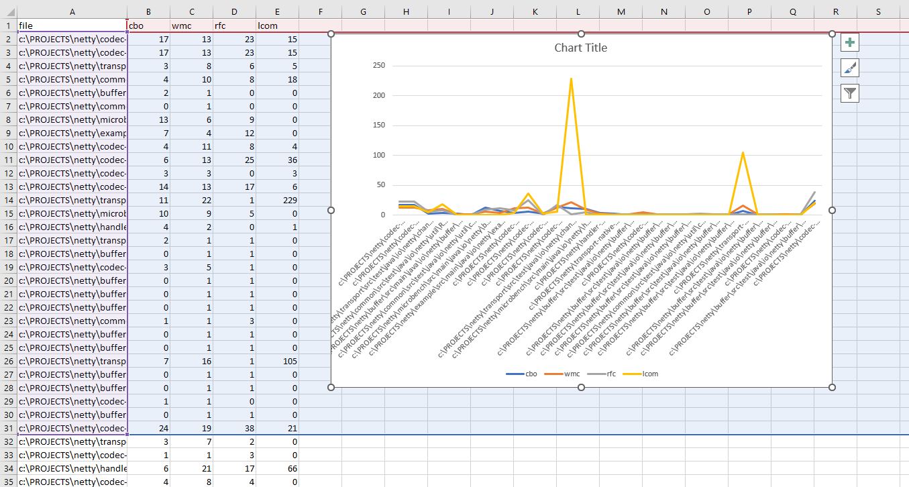

Project 5: APIJSON

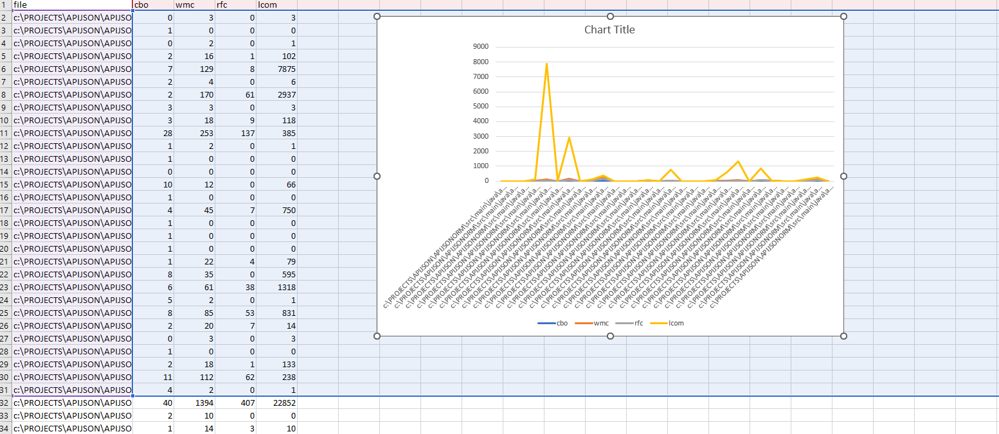

Conclusions:

Here we are considering WMC, RFC metrics. For the projects to be highly maintainable these metric values should be low.

In this assignment for the Project 1; the WMC,RFC values are moderate, so the maintainability is also moderate. Project2; the wmc values are low but the rfc values are bit high making it harder to maintain. Coming to project3, project4, project5; wmc and rfc values are very low making the project highly maintainable. The ck metric tool is very effective in measuring the attributes of the project. For measuring the maintainability WMC, CBO, RFC, LCOM metrics (in specific) should be taken into consideration. As I am considering WMC, RFC; these metrics should be maintained low for high values of maintainability. These metrics are inversely proportional to the attribute maintainability.

References:

* <https://github.com/mauricioaniche/ck>
* <https://github.com/confluentinc/ksql>
* <https://github.com/apolloconfig/apollo>
* <https://github.com/alibaba/arthas>
* <https://github.com/netty/netty>
* <https://github.com/Tencent/APIJSON>